1 SHE - READ

2 THEY - EAT


3 WE – DRINK

4 HE – WORK OUT

5 YOU – RUN

6 I – COOK

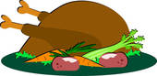
7 HE - PAINT

8 WE - LISTEN

9 SHE - FIGHT

10 YOU - TRAVEL


11 I – TAKE



12 THEY - SUNBATH
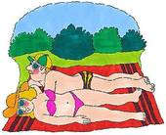
13 WE - STUDY

14 THEY – GO

15 I – PLAY

16 YOU - SLEEP
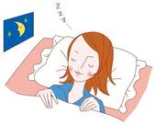
17 HE – WASH

18 WE – BUILD

19 YOU – WRITE

20 SHE – CLIMB

21 THEY- BAKE

22 HE – DRAW
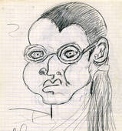
23 I – HAVE

24 YOU - MEET

25 WE – DO

26 I – WATCH

27 SHE – RIDE

28 IT – BARK

29 SHE – BUY
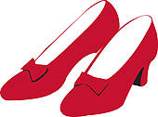
30 THEY – VISIT

HOME

ANSWERS
1
She is reading a book.

2
They are eating a pizza.
3
We are drinking lemonade.
4
He is working out.
5
You are running.
6
I’m cooking dinner.
7
He is painting the house.
8
We are listening to music.
9
She is fighting karate.
10
You are travelling around the world.
11
I’m taking a taxi.
12
They are sunbathing.
13
We are studying in the library.
14
They are going to the zoo.
15
I’m playing tennis.
16
You are sleeping .
17
He’s washing the car.
18
We are building a sandcastle.
19
You are writing a letter.
20
She is climbing a tree.
21
They are baking a cake.
22
He is drawing a portrait.

23
I’m having a shower.
24
You are meeting friends.
25
We are doing homework.
26
I am watching TV.
27
She’s riding a bike.
28
It’s barking.
29
She’s buying shoes.
30
They are visiting the pyramids.
HOME

Instructions for the teacher

Preparation
- Print the board games on tick paper or a cardboard; laminate them if you want to use them many times.
- Find tokens for each student.
- Provide dice.
- Divide the class into groups of 3 – 4 students each.
- Give each group a board game and a die.
- Give each student a token (or bean, coin, button, etc.).

The game
- The players put their tokens on the first square.
- The first student throws the die and moves his token ahead the corresponding number of squares.
- The student says what the person is doing in the given situation according to the pronoun and the picture..
- Example: She is reading a book.
- If the answer is correct, the student stays, if the answer is incorrect, he has to go back where he came from
- The first student who takes a number that places his token on “home” or surpasses it is the winner.

