English conversation 28 2 2023
Cooking
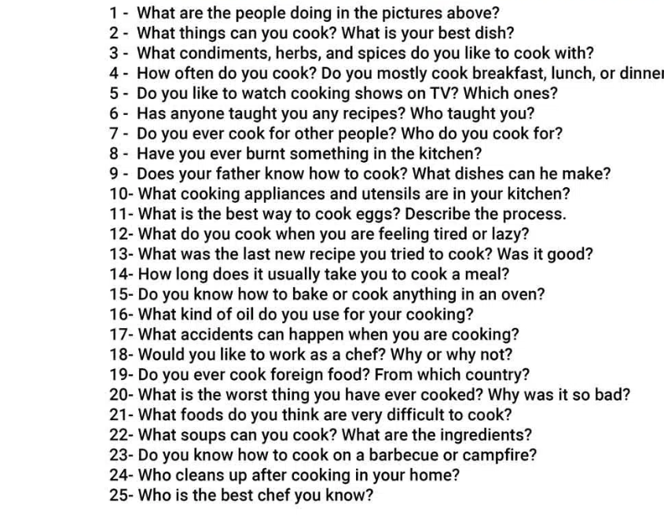

Do you cook? Why yes/ not? Is it a necessity/ hobby…
What is your most favourite and least favourite food?
What is your favourite meal of the day?
What are Czech eating habits?
When do we eat out mostly? For breakfast/lunch/dinner?
What is the best food you have ever eaten? In which restaurant?
Do you watch cooking shows? What is your favourite cooking program/ contests?
What kitchen utensils do you use when cooking?
LADLE WHISK GRATER SPATULA SPAGHETTI THONGS COLANDER MEATGRINDER PEELER CLEAVER
PANCAKE PAN
ROLLING PIN
GRATER
FISH POACHER
WHISK
EGG SLICER
SAUCE PAN
PASTRY BRUSH
SPAGHETTI TONGS
CORKSCREW

